STEP 8 – GLOBAL LAYER – CFS3 SDK tool MKGLOB
8.0-) To generate a CFS3 gsl.lib file for a new theater is to define the localization of the 1st airfield. You can use GM or Google Earth to get the coordinates and altitude. Make a note of these datas. Define the orientation angle, name, etc.
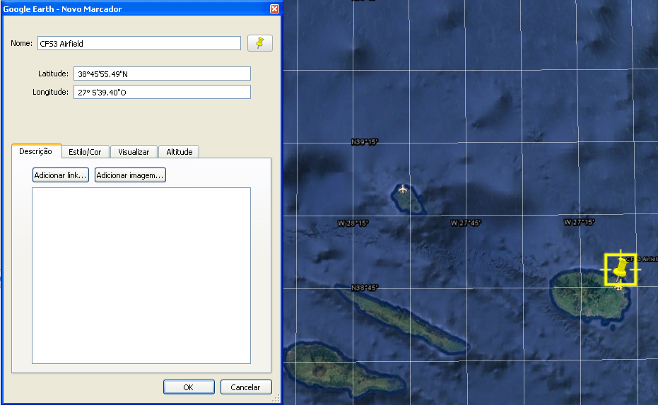
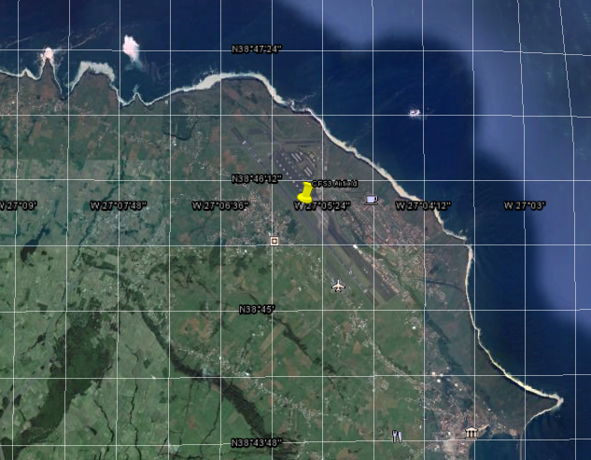

8.1-) Start Excel and import the attached global_layer.cvs ( Data tab – From Text button – Import global_layer.cvs – comma limiter). If you are using the attached excel file, only check the parameters.
TIP. For a new theater, use a global_layer.cvs with only one airfileld. After theater functionality checks, back to global layers and add the objects scenery that you want.

8.2-) Copy all DLL files from your working dir to GlobalLayer subdirectory. Also, copy and overwrite the original global_layer.csv by your 1st airfield global_layer.csv file.
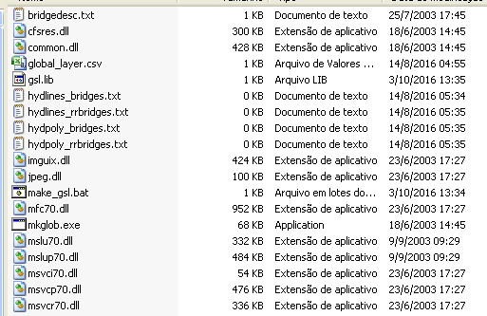

8.3-) Start your command line window on your working dir - GlobalLayer subdirectory. Just execute make_gsl command BAT file.
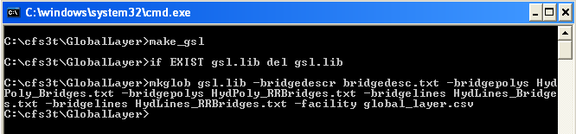
Check the size, hour and date of a new gsl.lib file generated. If no error message appears, you have a new gsl.lib of your 1st airfield.

8.4-) END OF STEP 8

